 | Disabled American Veterans, Department of Maryland,Inc.  Newsletter | Tel # 410-539-1310  Fax # 410-539-2106  Email Address: dav_md@verizon.net  1st DEC–10/19/08 11 AM  Omaha Beach Chapter #07  8205 Laurel Bowie Road  Bowie, MD 20715  Tele # 301-464-8899  Year 2008-09 Issue 1  Dated: Sept. 2008  Editor: Cmdr Gregory Jones  Adj. Lisa Gregory  Publisher: B. Iafolla

DAV, Department of

Commander Message:

Hello Comrades,

As I sit and ponder what to say to you in my first article as Department Commander, I am reminded that the responsibilities and duties of the Commander can be extremely daunting. As such, I will try to narrow the scope of my focus. But, first before I get into my message to you, I want you to know that I am deeply saddened by the deaths of Department 2nd Junior Vice Commander Thomas Unkle and Department Judge Advocate (Emeritus) Marvin Hout.

I know that depending on your particular religious faith, we all may see things a bit differently. None-the-less, I have been taught that death is a part of living and that death is not the end, but the beginning of everlasting life. And it is this belief that lifts my spirit each time I learn of the passing of one of our dear comrades. Thomas Unkle and Marvin Hout were extraordinary gentlemen who served this country well during extraordinary times. When I think of these two men, I am reminded of a quote by John Ruskin, who is best known for his work, during the 19th century, as an art critic, sage writer, and social critic, he said, “[t]he highest reward for a man's toil is not what he gets for it but what he becomes by it.” I believe their deeds will live forever in the annals of the Maryland Department of the Disabled American Veterans, and in our hearts. May God bless both of them and the family members they left behind. May you both have fair winds and following seas.

The Department together with the Chapters, as a team, must look to the future, our vision must be clear, we must trust one another, and we must ensure the preservation of our legacy.

Since the department convention, we have been extremely busy at the Department headquarters and we have a great deal of work ahead of us. The Department staff and I are extremely pleased to see that chapters are coming together with the Department, and are working together as a team. As we forge ahead this year, we are going to ask much of you. As we continue moving forward, we want you to keep in mind a quote by President John F. Kennedy. President Kennedy said, “[c]hange is the law of life. And those who look only to the past or present are certain to miss the future.” And a Japanese Proverb, “Vision without action is daydream. Action without vision is nightmare.”

We must be visionaries and one of our goals this year is to lay the foundation for a brighter future. All we ask of you is that you please do not be frightened by new ideas and look with a cautious eye at the old ones. With the help of the chapters, strengthening our foundation will be made easier than one might think, but we must work together. We must begin to trust one another. What do we mean by “trust”? By that we mean:
- Assuming that others will not intentionally hurt or abuse you if you should make an error or a mistake.
- The act of placing yourself in the vulnerable position of relying on others to treat you in a fair, open, and honest way.

During the upcoming Department Executive Committee (DEC) Meeting, we will ask you to be a part of and help set the course of increasing our legacy. I want to leave you with a quote from Napoleon Hill, an American author who was, during the 19th century, one of the earliest producers of the modern genre of personal-success literature. “Think and Grow Rich,” is one of the best-selling books of all time. Mr. Hill said, “[d]esire is the starting point of all achievement, not a hope, not a wish, but a keen pulsating desire which transcends everything.”

See you at the 1st DEC meeting in Bowie, Maryland October 19, 2008. Be there or be square. ☺

Yours, in comradeship,

Gregory N. Jones
Department Commander

MAY THERE BE

PEACE IN THE WORLD

IMPORTANT PHONE NUMBERS

Nat’l. Hdqrs., DAV (877)426-2838
DAV, Dept. of MD (410)539-1310
(800)328-6953
NSO Office – Baltimore (410)230-4440
NSO Office –Wash., DC (202)530-9261
VA Regional Office –Balto. (410)230-4500
(800)827-1000
VA Regional Office – DC (202)530-9260
Dept. of Veterans Affairs (800)446-4926
VAMHCS – Baltimore 1-800-463-6295
DAV Transportation (410)605-7000
HSC, Reginald Frazier (Ext. 6733)
BRECC (410)605-7000
VAMHCS – Perry Point 1-800-949-1003
DAV Transportation (410)642-2411
HSC, George W. Mitchell (Ext. 5384)
VAMC – Cambridge (410)228-6243
VAMC – Cumberland (301)724-0061
VAMC - Fort Howard 1-800-351-8387
DAV Transportation (410)477-7050
HSC, Franklin Martin (Ext. 7019)
VAMC – Greenbelt (301)345-2463
VAMC – Loch Raven 1-800-463-6295
VAMC – Charlotte Hall (301)884-7102
1-800-522-8387
VAMC – Hagerstown (301)665-1462
VAMC – Glen Burnie
DAV Transportation (410)590-4140
HSC, Tommie Hawkins (Ext. 4221)
VAMC – Pocomoke 1-877-864-9611
VAMC – Washington, DC (202)745-8100
VAMC - Wilmington, DE (302)633-5414
VAMC – Martinsburg, WV (304)263-0811
Telephone Care Line: To schedule Urgent Care Appt. call 1-800-865-2441

Prescription Refill Line: 1-800-463-6295,ext 7395
Have SS# & Prescription # ready, press option “2”
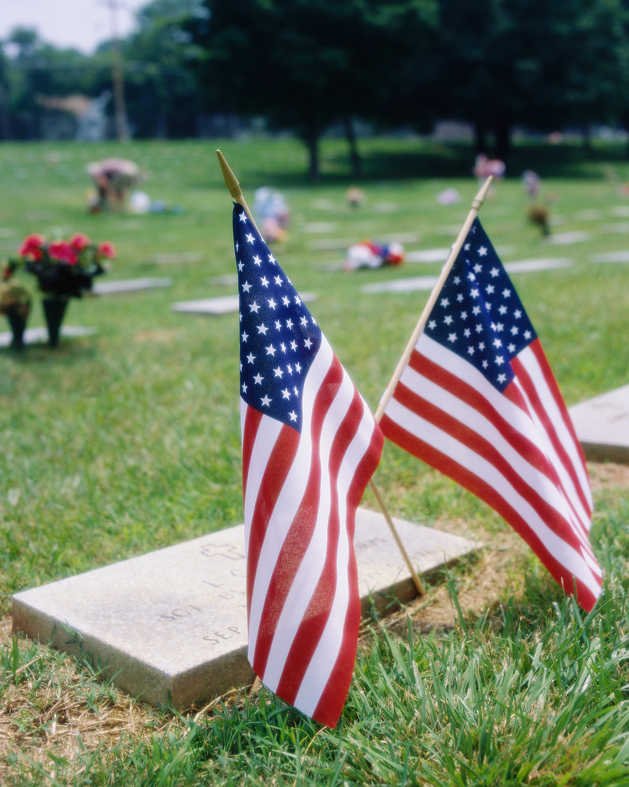
CEMETERY & MEMORIAL PROGRAMS
Robert L. Hooper III, Director
1122 Sunrise Beach Road
Crownsville, MD 21032
Anne Arundel County
410-923-6981

CHELTENHAM VETERANS CEMETERY
Martin F. Fahey, Superintendent
Cheltenham
Prince George’s County
301-372-6398

CROWNSVILLE VETERANS CEMETERY
Christopher T. Piscitelli
Superintendent
Crownsville
Anne Arundel County
410-987-6320

EASTERN SHORE VETERANS CEMETERY
Bruce W. Webster, Superintendent
Hurlock
Dorchester County
410-943-3420

GARRISON FOREST
VETERANS CEMETERY
Kenneth McKisser, Superintendent
Owings Mills
Baltimore County
410-363-6090

ROCKY GAP VETERANS CEMETERY
Ronald B. Platt, Superintendent
Allegany County
301-777-2185

MEMORIALS
Patrick M. Tracy, Superintendent
Baltimore, MD
410-354-3550

WAR MEMORIAL BUILDING
(WWI & II records, service metals)
Douglas W. Henley
Executive Director
Baltimore
410-396-8013
UPCOMING EVENTS
(DATES TO REMEMBER)


October, 2008

13 Columbus Day (Dept. Office Closed)

19 1st DEC – (11 AM) (DAV – DAVA)
Chapter #7, Bowie, MD

November, 2008

4 Election Day (Dept. Office Closed)

11 Veterans Day (Dept. Office Closed)

17 Golden Corral Military Appreciation Night

26 Thanksgiving Day (Dept. Office Closed)

December, 2008

- Christmas Day (Dept. Office Closed)
- Day after Christmas (Dept. Office Closed)



MARK YOUR CALENDARS

1st DEC (DAV/DAVA)
Hosted by Chapter/Unit 7

1st DEC–10/19/08 11AM
Omaha Beach Chapter #07
8205 Laurel Bowie Road
Bowie, MD 20715
Tele # 301-464-8899

All DEC Reports are due into the Dept. office NLT 10/03/08. You may fax (410-539-2106) or email (dav_md@verizon.net) your report to the Department Office.

Mid-Winter Conference
January 15-17 2009
Princess Royal Oceanfront Hotel & Conference Center
9100 Coastal Highway
Ocean City, MD 21842
Tele: 1-800-476-9253 or 410-524-2544

All Reservations must be made NLT December 1st, 2008 in order to get discounted group rate. The discounted room rate is $74.00 per night for Poolside and Ocean view. To make your reservations, please call the Princess Royale Reservation desk at 1-800- 476-9253 or 410-524-2544 ASAP. Call the Hotel if you do not received your confirmation.

All DEC Reports are due in the Dept. Office NLT 1/2/09. You may send them by fax 410-539-2106 or email to dav_md@verizon.net .

Lisa M. Gregory, Dept. Adjutant

We have had an extremely busy summer and I want to extend my thanks to all who supported the DAV Night at the Ballpark events. The Department hosted five games total and each was well received by our members. Of course we will continue to support this program and now is the time for your input as to which games you would like to see on the calendar. Let me know your home team favorite and we will work with them to schedule a game for next season.

Many of you also attended the National Convention in Las Vegas, Nevada this year and I’m sure you left there with a wealth of information. Please be sure to share what you learned at the different training events with your fellow chapter members. There are some great new programs out there and they are designed to better assist us with taking care of veterans. For a preview of these programs I highly recommend visiting the National website at www.dav.org. There is a host of information there to include the membership system, news releases and current events on veterans’ legislation. These are great resources to keep in your personal toolkit for helping veterans.

Over the past few months I have noticed a variety of other resources and programs that are now available to veterans and their family members. These are benefits that many of you out there have lobbied for and we now have them. Check out the Maryland State Veterans Affairs site at www.mdva.gov to see what is available to you.

Lastly, we come to the matter of paperwork. Annual Financial Reports are due to the Department by September 30 of each fiscal year. Please be sure to follow the instruction guidelines sent with your forms and should you have any questions please contact me for assistance. Without your paperwork completed the chapter cannot sign in delegates to the DEC meeting. And if your report is due to National you are subject to having your charter suspended until the report is received. I am here to work with you to ensure your chapter paperwork is in order.

Thank you for everything you do for veterans and have a great Army day!!!

Lisa M. Gregory
Department Adjutant

NOTICE! NOTICE! NOTICE! NOTICE!
All DAV Chapters are now required to file the 990-N. This is an electronic postcard and can only be done through the Internet. We will have a station set up at the DEC with instructions for filing. If you wish to file the 990-N on your own the Department has a listing of all EIN's for chapters in the state. You will need an email address to receive your return receipt once you have filed. More information can be found at www.irs.gov. The deadline for filing the 990-N is November 1, 2008.
DEPT. SVC AND JR VICE’S

Dept. SVC – Robert L. Wilcoxen

We are saddened here at the Department of Maryland at the recent loss of 2nd Junior Vice Commander Thom Unkle. Our sincere condolences go out to his family at this time. It goes without saying that Thom will be missed by all as will his contributions to the DAV community.

Since the Election in Ocean City, I have been busy working with the veterans throughout the state. Below is a sampling of some of the things that I have attended.

JUNE
11 - Visited the Department Office
14 - Attend and participate in the Flag Day
Celebration in Leonardtown, distributing Flag
Etiquette brochures and flag book markers
21 - Attended the staff meeting at DAV Chapter
#7 Home in Bowie, MD
25 - Visited Charlotte Hall Veterans Home

JULY
14 – Finance Meeting at DAV Chapter #7 Home
in Bowie, MD
18 – 22 Attended the Commanders & Adjutants
Orientation in Kentucky.

AUGUST
4 – Training at Department Office to fill in for the
Office Administrator
6 – 13 Attended National Convention in Las
Vegas, Nevada
19 – Work at Department Office
21 – Work at Department Office
26 – Work at Department Office
28 – Work at Department Office

SEPTEMBER
4 – Attended Memorial Service for Thom Unkle;
Work at Department Office
8 – Work at Department Office
11 – Welcome home troops at Patuxent River
Naval Air Station

Respectfully submitted,

Robert Wilcoxen
Senior Vice Commander

1ST JVC – Flip P. Micocci

Since becoming 1st Jr. Vice Commander at the last Convention, my NSO Office responsibilities have kept me hopping working on veteran’s claims, and as you can read in my NSO article setting up CSO training in the fall. However, busy as I am, I visited the State Headquarters and met with Senior Vice about membership and attended Thom Unkle’s funeral. I am looking forward to visiting & working with my assigned chapters in the near future and fulfilling all my responsibilities as Department 1st Jr. Vice Commander.

Yours in Comradeship,
Flip Micocci
1st Jr. Vice Commander

2nd JVC – Gary Roundtree

Since becoming 2nd JVC I have scheduled all my chapter visit between July and October. I have scheduled an Area Meeting October 4, 2008. I've attended meeting of the Joint Veterans Committee and planning to attend Legislation Night in Annapolis, Welcome Home Event for returning combat veterans and their families this Saturday, September 27, 2008 at the Navy-Marine Corps stadium in Annapolis, MD. Became a US Army ambassador CRSC volunteer this month to further help wounded soldiers and families. I have taken a lot of picture of the DAV Department at work helping veterans, and conferences, Installations and sent in application to the United States Department of Veterans affairs Chaplain Service, President Michael L. McCoy and began working with church leaders on how to help veterans and families in their congregations.

Yours in Comradeship,
Gary Roundtree
2nd Jr. Vice Commander

3rd JVC – Jacinta McCreary

I will keep this brief and to the point, since I have become 4th/3rd Jr. Vice Commander I have attended 1 staff meeting on June 21st in Bowie, Area 6 District meeting August 8th, and the National Convention August 9th-13th.

At the District meeting I was elected as an Alternate to the National Nomination Committee.

I have scheduled the following chapter meeting visitations:

October - 2nd Chapter 13; 6th Chapter 3; and
28th Chapter 17.
November - 5th Chapter 26; 11th Chapter 33; and
20th Chapter 36.

Area 4 meeting has not been scheduled to date.

Yours in Comradeship,
Jacinta M. McCreary
3rd Jr. Vice Commander

Dept of Maryland – Admin Asst.
(Cookie) B. Iafolla

Welcome aboard Chapter #37; looking forward to seeing your cycles at the 1st DEC in Bowie,

Important Department Information, please note:
- The 2nd Qtr Department Newsletter will be published on 12/6/08, any articles or information must be submitted to the Department Office NLT 11/21/08, mark your calendars.

- Reports for Mid-Winter Conference packet due into the Dept. Office NLT 1/2/09, mark your calendars.

- Do we have your current email address? If not, call the Dept. Office or send us an email with your email address, this way we can keep you informed of happenings within the Department, Chapters, Units and State of Maryland. Also, please inform the Department of any address change, telephone number etc.

- Please let us know of members of your Chapter or Unit who are ill or hospitalized, or pass away, we would like to send them or their family a card and to let other members of DAV/ DAVA know and place their names on Deceased List and in the Newsletter.

- If you’re not getting DAV National Magazine, call National Headquarters at 1-877-426-2838 Membership (Ext. 3323). If you need September/October National Magazine, we have some on hand, call us at 410-539-1310 and we will send you one.

Ciao Everyone,

My trip to Italy was great, thanks to all who filled in for me, I really appreciated it. The plane trip was a little nerve racking for me since I don’t like to fly, but it was worth it to see family and friends again in beautiful Villalago, Italia. We took several day trips; I hated the walking especially the 129 steps to my mother in-law’s house, but I loved what I saw there. We have seen Rome, Pompei, Naples, Milan, Pescara, in our visits to Italy in the past. This time we visited a lot of small towns & out door market places and Churches while we was there, I saw the Church of St. Padre Pio in Pietrelcina and St. Gabrielle. I can only tell you that the scenery of the mountains was breathtaking, the sky is so blue, and the lakes are so clear you can see the fish in it, and when there was rain, it didn’t last too long, the thunder, and fireworks, echoed through the mountains of Villalago, I loved that. Its festival time (August/September) in Italy, there’s music, carnival and lots of visitors from the United States, Canada and Australia. I loved all the Italian food there, (my mother and sister in-law are great cooks) I ate plenty fruits and vegetables and meats fresh from the market place and of course the best pasta, pizza and breads ever. It took some time for me to get used to the time change (6 hrs ahead) and when their meal times are. In the morning I get my Cup of Tea and a pastry or piece of fruit, I love how everything stops in midday from (2 to 4) to enjoy the day, everyone goes home enjoys midday meal and has time to enjoy the day for a couple of hours, they can eat, take a nap or just relax with a book, do things they need to do, then go back to work for a few hours. They eat the evening meal around 8 pm that took a lot to get used to. In the evening you gather together in the Square (center of town), take a stroll, and go to a cantina or pizzeria for an espresso, caffe, a berra or vino, (cin, cin, - Cheers). They usually call it a night around 12 or 1 pm, and say Buona Notte (Good Night). I had a wonderful time in Italy, and can’t wait until I can go again. Arrivederci, Italia

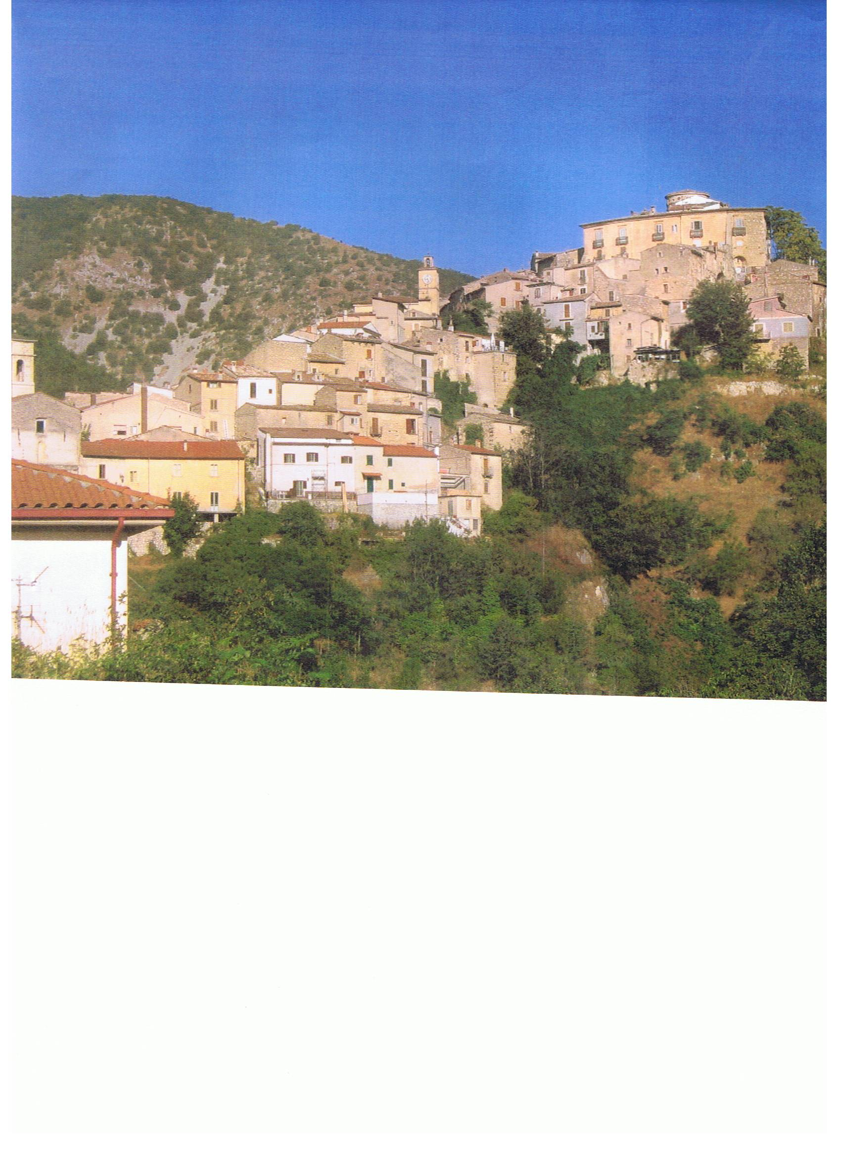
Villalago is a little Historical town between two lakes, Lake Scanno and Lake St. Dominico; it is in the Abruzzo Province, in the Apennines Mountains about 2 hours from Rome. I will bring some pictures of my trip to the 1st DEC and Mid-Winter Conference. Italy is truly beautiful. The people of Villalago are friendly and most know a little English since many families have migrated to either the States, Canada or Australia, so if you plan on going to Europe don’t let not knowing the language stop you…it’s not a problem, but Italians really appreciate it if you at least try to speak Italian. It is a beautiful language…and they really do speak with their hands when they talk. They are very expressive people.

The Picture above is the town of Villalago; it lies in the Abruzzi Region of Italy which is located in the center of the boot – my mother-in law lives in front of the town clock. The people who were born in the town are known as Villalagese. The Patron Saint of Villalago is San Dominico Abate. The month of August to Sept 5 is considered Holiday in Villalago, they celebrate San Dominico Feast during that time, among other Feasts. Those people who have migrated to other countries such as Canada, Australia and the United States come home to Villalago for vacation at this time, so there are a lot of English speaking people in the town at this time….Good for me since I speak very little Italian, or as they say in Italian… parla poco Italiano.

I was so saddened to hear that Thom Unkle had passed away while I was away. I kept the DAV Department, Chapter 13 and all Thom’s family in my daily prayer. I’m so sorry I wasn’t here to pay him my last respects, because he was my friend and he was a very good man, a little rough around the edges and colorful at times but in his heart, he was kind and caring of the DAV, and all the veterans in the State of Maryland. He worked hard in his duties as Jr. Vice Commander, he worked hard for the Department and his chapter #13 in Glen Burnie, in which he was very proud to be called their Commander, and it was important to him that we promote Americanism to youths in our schools. He was proud of the American Flag, the veterans who served in all branches of Armed Forces especially his beloved Marine Corp. May he rest in eternal peace and be rewarded for his efforts done here on Earth.

God Bless you Thom for all you did for the DAV and DAVA members. I hope you knew how appreciative we were for your services given; you will be truly missed by many.

When I got back I was also informed that Major Marvin Hout, who was a past Department Judge Advocate for the Department of Maryland passed away on September 14, 2008, my heartfelt Sympathy goes out to his family also. Unfortunately I never met this fine person, but I would like to recognize him in this newsletter also for the service he gave to the DAV, Department of Maryland so therefore this newsletter, I dedicate to 2nd JVC Thomas Unkle and Past Judge Advocate Major Marvin Hout, may the Lord’s peace be with you both always,

Respectfully,

(Cookie) Beulah Iafolla
DAV, Department of Maryland

In loving Memory we look to heaven for our comrade & dear friends – Dept. 2nd JVC Thom Unkle & Past Judge Advocate Marvin Hout

PEACE BE WITH YOU BOTH

When we look to the Heavens in Prayer,
Let us take time to think of Thom and Marvin who has passed on to their final honor, they served the DAV, Dept. of Maryland well, and remember also those veterans who served our country in the past and those who are now serving their country proudly and have sacrificed much for others, and give thanks to them for their service. Remember that everyone has goodness within them; let us look for that goodness always.

Amen.

Thomas Unkle – Dept. 2nd JVC and Commander, Chapter # 13

Thomas Unkle served in the Marine Corps, he was a Vietnam veteran. He was the owner of Viking Construction and Improvement.
Thom Unkle was an avid member of the Purple Heart and the Disabled American Veterans, where he was commander for Chapter 13 in Severn, and served as Department of Maryland, 2nd Jr. Vice Commander. He also was a member of the American Legion, Post #40, Veterans of Foreign Wars, Post 160 and the Marine Corps League.

He enjoyed watching football, reading, doing word searches, listening to opera and doing karaoke. He was preceded in death by one daughter, Wendy Millard, living are his two sons, Thomas Unkle Jr. and Matthew Unkle and three daughters, Elaine Fleming, Renee Mason, and Chantel Harris. Our sincere condolences we send to his family & friends.

The following was sent in from a dear friend, Ms. Pat German in memory of Thom Unkle.

A man with a colorful past can be changed in the blink of an eye when God is walking beside him enhancing his spirit to try.

Walking tall in the love of creation; wanting a change that won’t fail; leaving behind the temptations that keep tagging along on the trail.

Remembering that little voice softly keeps saying, you’ve always been mine, why do you walk in the darkness? For, I need your light to shine.

Stand tall in my arms, for protection, let me keep you in my world supreme, let peace, joy and happiness surround you.

It’s what made you that “Proud Marine”.

In Pat’s letter she said Thom was a very nice and caring man, and it was a privilege to know him, I agree with Pat, it was indeed a privilege to know Thomas Unkle, even though he was a little colorful at times, we must look deeper at the heart of the person and at the goodness he did for others not for notoriety, but out of caring. Thom Unkle didn’t care what others thought about him, their views of him didn’t matter….but he cared about the DAV and the veterans of this State, and most important his actions of commitment to others showed what type of person he truly was, and he was most certainly a Proud Marine, proud to be called DAV member and most important a proud American.

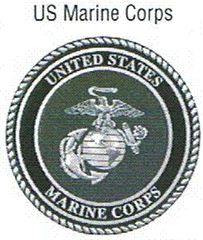 DAV 

Major Marvin Hout, USAF Retired
Past Dept. Judge Advocate

Major Marvin J. Hout, USAF served our country for 22 years on active duty. He enlisted in the US Army in 1942 and after basic training was selected for Officers training, in 1943 he was commissioned a second lieutenant and assigned to the 87th Infantry Division as Platoon Leader. Lt. Hout was then selected for an overseas assignment to England and was assigned to the 1110th Engineer Combat Group as a Platoon Commander. He received five battle stars for participating in all five of the official battles of the European Campaign. He was awarded the Purple Heart Metal for wounds received in the Battle of the Ardennes (Battle of the Bulge).

After the German surrender, Lt. Hout rotated back to the United States and was stationed at Francis E. Warren Air Force Base, Wyoming where he was assigned to the 809th Aviation Engineer Battalion. He received another overseas assignment while in the 809th AEB and upon returning to Warren AFB transferred from the US Army to the US Air Force in 1950, Captain Hout was chosen as the Base Provost Marshal at the newly formed USAF base at Cheyenne, Wyoming. The Korean War was now emerging and in 1952 he was selected for an overseas assignment at Furstenfeldbruck, Germany where he commanded the Security Police Squadron for the USAF 36th Fighter Bomber Wing. He also had the responsibility and jurisdiction over two other supporting Air Fighter Bomber Wing. He also had the responsibility and jurisdiction over two other supporting Air Bases in Germany. After the completion of this assignment in 1955, he was assigned to Bosier Base in Louisiana. While there Captain Hout completed his college work and was awarded a Bachelors Degree from the University of Nebraska. After three years of study by correspondence, he was awarded a Bachelor of Law Degree from LaSalle Extension University, Chicago, Illinois.

After four years at Bosier Base, he was then assigned to the Air Staff, Headquarters, USAF, at the Pentagon and was promoted to Major. One of his last major activity duty assignments was developing, structuring and staffing the Air Force Regulation setting forth the physical security for the Presidential Aircraft, Air Force One. Major Hout was awarded the Air Force Commendation Metal. He retired from the Air Force in 1963 and was immediately employed as a civilian by the Office of Aerospace Research. While in this employment he was awarded the Air Force Outstanding Unit Citation. He was promoted and was subsequently employed by the Office for Security and Trade Affairs in the Pentagon. He retired a second time in 1974. In addition to becoming involved with veterans’ organizations he was a volunteer member of Greater Washington Area Executive Board of the Muscular Dystrophy Association.

Since moving to Bowie, Maryland, Mr. Hout was extremely active and productive in several veterans’ organizations at both the local and state level. In 1997, he held elected and appointed positions in the Disabled American Veterans; he was chapter #7 in Bowie Judge Advocate and Department of Maryland’s Judge Advocate. He was chosen as Joint Veterans Committee of Maryland, Inc. – The Veteran of Year for 1997. He was a charter member of the VFW, Post 8065 he was the local Post Advocate, and of the Military Order of the Purple Heart Stars and Stripes Chapter 2222 as the State Judge Advocate. He was also a member of various Executive Committees at the local and state levels and participated very actively in these environments.

For over four years, Mr. Hout was the Executive Producer and co-host of a local television program called “VETERANS FORUM” which was carried on the local Bowie Cable Television Station 15B. This was a program “by veterans, about veterans, for veterans and their families and friends”. This program aired about three times a week throughout the year in Bowie and at times in Prince George’s County. The program received many awards. Guests were the Security of Veteran Affairs, State Commanders of veteran’s organization in Maryland, Director of Charlotte Hall Veterans Home and Director of the Maryland Homeless Veterans in Baltimore.

Mr. Hout was married to the former Mary Smith of Champaign, Illinois. They celebrated many anniversaries together. They lived in Bowie Maryland for many years; they have 1 daughter, Roxanne who is married with 4 children and lives in Davidsonville, Maryland. Our sincere condolences are sent out to his family and friends.

 DAV

MAY THESE TWO FINE MEN REST IN PEACE KNOWING THAT THE SERVICES THEY GLADLY PERFORMED WAS DEEPLY APPRECIATED BY THEIR COUNTRY, THOSE IN THE DAV, AND MOST OF ALL THE VETERANS OF THE STATE OF MARYLAND IN WHICH THEY SERVED SO WELL.

THANK YOU FOR A JOB WELL DONE!

Message from Dept. Chaplain:
Alfreda M. Alexander

O, give thanks unto the Lord; for He is good; for His mercy endureth forever.
Psalms 136:1

Hello, Comrades. I pray all is well with each of you and that each of you are embracing God's blessings everyday. Many of our comrades have fallen from the ranks since we were together at our convention in Ocean City. I pray that each of our fallen heroes is resting in eternal peace. I do not know what was said at each of their funerals or memorial services, but I pray there were many good things said about them. While each of us are at individual stations on the time line of our lives, it's not too late to think about the things that will be said when we are memorialized. Please read the following poem and take heed to its message while asking yourself, "how is my dash?".
How is your dash?
I read of a man who stood to speak
At the funeral of a friend.
He referred to the dates on her tombstone
From the beginning...to the end.
He noted that first came her date of birth
And spoke the following date with tears,
But he said what mattered most of all
was the dash between those years.
(1934 -1998)
For that dash represents all the time
That she spent alive on earth...
And now only those who loved her
Know what that little line is worth.
For it matters not, how much we own;
The cars...the house...the cash,
What matters is how we live and love
And how we spend our dash.
So think about this long and hard...
Are there things you'd like to change?
For you never know how much time is left,
That can still be rearranged.
If we could just slow down enough
To consider what's true and real,
And always try to understand
The way other people feel.
And be less quick to anger,
And show appreciation more
And love the people in our lives
Like we've never loved before.
If we treat each other with respect,
And more often wear a smile...
Remembering that this special dash
Might only last a little while.
So, when your eulogy's being read
with your life's actions to rehash...
Would you be proud of the things they say
about how you spent your dash?
Author Unknown
May God continue to bless each and every one of you.
Chaplain Alfreda M. Alexander

In remembrance
Of all our
Fallen heros
May they
Rest in peace

FOR THOSE WHO ARE ILL, IN HOSPITALS OR RECOVERING FROM AN ILLESS OR SURGERY, YOU ARE IN OUR THOUGHTS & PRAYERS…

Chapter 7 PDC Bill Meyers

Chapter14 Stephen Hansen (Cmdr)
Richard Robinson
Basil Kukn
Ora Delauter
Wilbur Mitchell
Fred Wisherd
Wayne Alter
Dale Everett
Stanley Jones
Clarence Schroyer

Unit 17 PSC Hazel Meyers

Unit 22 Elizabeth Houck

Chapter 23 Joseph Ranselle

Chapter 26 Robert L. Wilcoxen (Dept. SVC)

Chapter 30 Dennis W. Story (Cmdr)

And to all the other DAV/DAVA Members who are not listed above that is ill, or who was hospitalized and is in the recovery stage,

GET WELL SOON,
THE DAV/DAVA NEEDS YOU…
“May our Comrades and Friends
Rest In Peace”
YEAR 2008-2009
Chapter #01 Odis Lee, Sr.
Chapter #3 James W. Pierce
Robert L. Garrison Jr.
Chapter #7 Major Marvin Hout (Past Dept.-JA)
Chapter #13 Watson E. Mowbray
Thomas Unkle (Chapter #13 Cmdr &
Dept. JVC)
Chapter #14 Roger Rivera
James Roby
Edward James
James Paff
John Glynn
Wilbur Mitchell
Frederick Le Neane
Allen Clingerman
Chapter #17 PCC Thomas W. Southall Jr.
Robert L. Reid
Chapter #22 PCC Russell E. Shaffer
Chapter #23 S. E. Harris
John P. Holland
Dermot A. Murray
James D. Schultz
John T. Wilson
Chapter #26 PCC James Ham
Chapter #36 Philip H. Ayers (6/18/08)
Unit # 22 Eva Owings
Unit # 18 Grace Hyle
Unit # 6 Goldie Delauter

“Heavenly Father, in your hands is the souls of the living and the dead. We pray that you will give your healing to those who are ill and that the souls of our departed comrades are with you in the place you have prepared for them, lift up the hearts of those burdened with sorrow and grant them Peace.” Amen….
DEPARTMENT COMMITTEES:

Legislative Committee
Chair - PDC Glynn E. Parker

Look at all the Legislative bills that are of concern for the Veterans in the State of Maryland, and do the following:

Go to the Rally’s, write letters, make calls and voice your opinions to your Legislators, and make them listen to you. Let your voice be heard by those who are making the decisions that concern all the veterans.

To build better lives for Veterans & their families, we need a Legislative Body who feels the same way as we do! Do you know how your Legislators are voting on Veteran Issues? If not –
GET INVOLVED!

Membership Committee
Chair - SVC Robert Wilcoxen

First of all, I would like to congratulate and welcome our new chapter, Chapter #37, Road Hogs to the Department of Maryland. We have a challenge to meet again this year as the total members for the Department last year was 18,715. National shows the total membership for the current year as 15,655. Our full life membership stands at 13,250 and National has set our goal this year at 13,468 (as of 9/2/08).
What this means is that we have to start early to make our goal and keep working at it throughout the year. The first chapter recorded at reaching goal is our new Chapter #37.

We would like to see all of our chapters make goal as early as possible. We still have the same membership program in the Department, and that is the Chapter pays part of the members’ dues, and the Department will match the member’s dues up to $30.00 in order to help you reach your goal.

There will be an update at each of the DECs. Remember our membership year does not expire until June 30, 2009.

Without members and member support, our chapters cannot exist. If our chapters don’t exist and maintain members, there will be no Department of Maryland. It is through our members that we are able to be “Veterans helping Veterans”, and helping to “build better lives for our Disabled Veterans and their families”. Comrades please keep up the good work that you have been doing and have done in the past. Together we can reach our membership goal.

Yours in Comradeship,

Robert (Bob) Wilcoxen
Senior Vice Commander

Golden Corral Committee
Chair – CMDR. Gregory N. Jones

Once again the DAV is proud to participate in Military Appreciation Night, November 17th with the Golden Corral.

In order to prepare for this event there will be a Golden Corral Committee Meeting on October 15th at 7:30 p.m. at Golden Corral, Arundel Mills in Hanover.

Any Chapter that will be participating in this event is welcome to attend as well.

DAV Transportation COMMITTEE
Chair - PDC George W. Mitchell

WE NEED VOLUNTEER DRIVERS…

If you are interested, please call the numbers below:
Baltimore - 410-605-7000 Ext. 6733
Ft. Howard - 410-477-7050 Ext 7019
Glen Burnie – 410-590-4140 Ext 4221
Perry Point – 410-642-2411 Ext. 5384

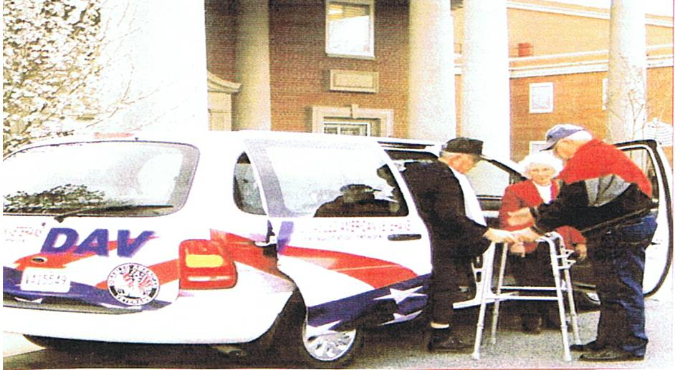

DAV, Dept of MD-Veteran of the Year
Chair – PDC Glynn E. Parker

All Chapter Commanders, we know that there are those within your chapters who you could nominate for this award, so start looking at your members as potential nominees for the DAV, Department of Maryland Veteran of the Year Award. If you feel that someone in your chapter is worthy of this award please send a letter and resume stating their accomplishments within your chapter, the Department, and other veteran organizations, listing how they are helping the veterans in the State. Remember that the person who receives this award, their name will be submitted as the Department’s nominee to the Joint Veterans Committee of Maryland for their Veteran of the Year award, so they should have the needed qualifications for that award as well. Please forward your nominees ASAP to the Department, they will see that this Committee receives them.
DAV, National Guard Committe
Co-Chair –1st JVC Gary Roundtree

My Dear Fellow Comrades, What a pleasure it is to report, how smoothly things are going for the National Guard Committee, this year. Being the Co-Chair I assist the Chair Filippi P. Micocci with the committee, in carry out the duties required by the DAV Dept. of MD Inc. From accepting his appointment as chair of the committee, Filippi has laid out a clear and precise plan and vision for all committee members to be engaged and involve with the National Guard bases in there respective areas. Working closely with top people of the Governors Staff and National Guards Adjutant General staffs for reintegration of troops coming home has remove quite a bit of past obstacles that have hinder some progress before. This year as chair and co-chair we have made it a priority to be participating in everything the National Guard or Maryland Department of Veterans Affairs has for the troops, families and veterans. These are some events attended this year 3rd fundraising Golf Tournament for NGAUS Conference, Muster at Lutherville, MD, Re-National Guard Reintegration Phase 2-July 19- Sheraton Hotel, Baltimore MD, and Carroll County muster, August 16 at Westminster Senior Center, Dorchester County Muster at Cambridge, MD. September 6 was cancelled because of Hurricane IKE off the coast, and this Saturday I and some DAV commanders attended the Welcome Home Event at the Navy-Marine Corps Stadium in Annapolis MD.

Yours in Comradeship,

CO-Chair Gary Roundtree Sr

Disabled American Veterans Auxiliary
Betty Swift, State Commander

I am honored to serve the Auxiliary again this year 2008-2009, as most of you know this is my third term as Auxiliary Commander. I would like to thank everyone for a successful convention again this year, without your dedication and hard work the goals of the Auxiliary to continue support of the Veterans and their families would be hard to realize. If I can be of assistance to anyone, please feel free to contact me.

Auxiliary staff and members have recently returned from National Convention in Las Vegas, NV. Sandra (Sandy) Dobmeier was elected as National Commander. Barbara Forbes (Maryland Unit #17) was elected as 6th District National Executive Committeeperson. This was the first convention that newly appointed National Adjutant Judy Hezlip presided over; she did a great job, kudos Judy.

MEMBERSHIP, MEMBERSHIP, MEMBERSHIP, this is a priority, the DAV is one million strong, since the Bylaws were changed in 2005, there isn’t any reason why the Auxiliary can’t be at least half that or more. If you need additional information on Membership, speak with the Membership Chairman, Sr. Vice Commander Ruth Wilcoxen (240-895-0058), Adjutant Carol (410-357-8546) or myself (410-557-6552). Thanks to all Units in the State for helping National to meet the National Membership quota. Membership lists and labels can be obtained through National at no/minimal charge, if you have problems navigating the website, contact Ruth, Carol or myself.

National Fall Conference will be held in Cincinnati, Ohio, October 2-4, 2008, hope to see you all there.

Yours in Comradeship,

Betty Swift
DAVA State Commander

DAVA

National Service Office
Baltimore, Maryland

Comrades,

Greetings! As always, I hope all is well with you and yours.

Coming soon this fall we will be doing our annual CSO (Chapter Service Officer) training. A Chapter CSO, as well as others in the Chapter who step up to the challenge of being involved and active, are worthy of respect. I believe an active Chapter CSO can be the catalyst for getting new members to come to the meetings…and keep coming.

The first thing you should do if you would like to participate is to check with your Chapter Commander and make sure you are on your Chapter’s roster as a CSO. Then, have your Commander verify that the State Department has the updated roster. Only people who have their names on the Chapter roster as a CSO will be allowed to participate in the training. If you are a returning CSO, make sure to bring your CSO training book! If you are a first time CSO, please let me know. You can contact our State Department, and they will let me know. 410-539-1310

This year I am trying to make it easier for members to attend the training by having the training in different parts of the state. Let’s face it; Maryland has some very unique boundaries (eastern shore, western shore, west northern tip, etc.). So I will come out to certain areas through the months of Oct. to Dec. and do the training. The training will be done on Saturday or Sunday. I figure it is easier for me to travel than it is for many in the state to travel. I hope this will increase the amount of members who would like to be a CSO. The more the better!

Please contact your Commander for times and locations for your specific Chapter.

Thank you to all of you who put forth the effort to keep your Chapter active.

FLIP MICOCCI
DAV NSO SUPERVISOR
MARYLAND

Mobil Service Office

Unfortunately, we haven’t been given the schedule for future Mobil Service visits, but when the Department receives it, it will be sent out to all the chapters and units.

If you already are working with the DAV, National Service Office, it is better to call the DAV, NSO Office at 410-230-4440. The MSO truck is out there to meet new people and will not be able to check on a claim or anything for those who already have pending claims.



Support Our Troops All Over The World…

Remembering those who have given their all and those who are still in harms way.

Remember
Those who are serving now and those who have served
On
Veterans
Day.
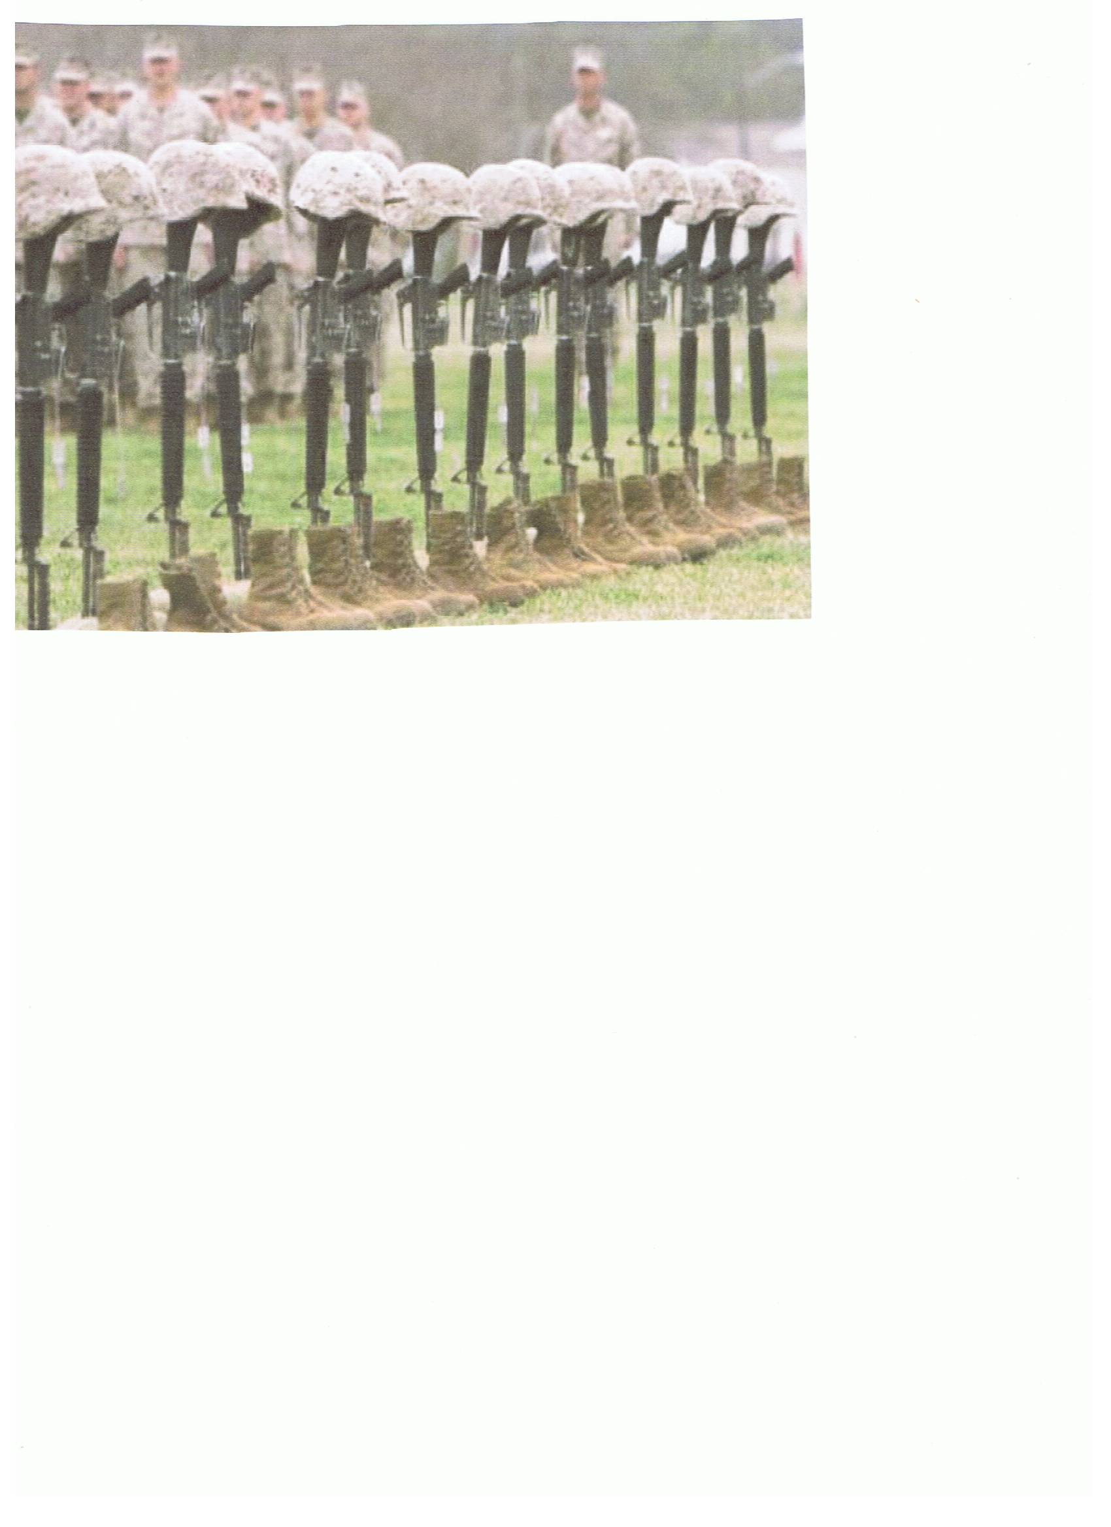

READ ALL ABOUT IT…

From National Headquarters:

Lisa Bogle, DAV Headquarters is doing an outstanding job of keeping everyone informed of Legislation that needs our vote. If you visit the website www.standup4vets.org, it allows you to take action. When you click on the Take Action tab, it will ask you for your zip code. When you follow the on line instructions, it will automatically generate an email to your representative at the federal level so your voice can be heard. You can use the letter they provide, or you can make up your own. Please pass the word and support the bills that will ultimately build better lives for our veterans.

From Veterans Affairs:
Website: www.mdva.state.md.us

Special Extra Earnings for Military Service

Since 1957, if you had military service earnings for active duty (including active duty for training), you paid Social Security taxes on those earnings. Since 1988, inactive duty service in the Armed Forces reserves (such as weekend drills) has also been covered by Social Security.

Under certain circumstances, special extra earnings for your military service from 1957 through 2001 can be credited to your record for Social Security purposes. These extra earnings credits may help you qualify for Social Security or increase the amount of your Social Security benefit.

Special extra earnings credits are granted for periods of active duty or active duty for training. Special extra earnings credits are not granted for inactive duty training.

If your active military service occurred

- From 1957 through 1967, we will add the extra credits to your record when you apply for Social Security benefits.
- From 1968 through 2001, you do not need to do anything to receive these extra credits. The credits were automatically added to your record.
- After 2001, there are no special extra earnings credits for military service.

How You Get Credit for Special Extra Earnings

The information that follows applies only to active duty military service earnings from 1957 through 2001. Here is how the special extra earnings are credited on your record:

Service in 1957 though 1977

You are credited with $300 in additional earnings for each calendar quarter in which you received active duty basic pay.

Service in 1978 through 2001

For every $300 in active duty basic pay, you are credited with an additional $100 in earnings up to a maximum of $1,200 a year. If you enlisted after September 7, 1980, and didn’t complete at least 24 months of active duty or your full tour, you may not be able to receive the additional earnings. Check with Social Security for details

When a Soldier comes home, he finds it hard…

..to listen to his son whine about being bored.

…to keep a straight face when people complain about potholes.

…to be tolerant of people who complain about the hassle of getting ready for work.

…to be understanding when a co-worker complains about a bad night’s sleep.

…to be silent when people pray to God for a new car.

…to control his panic when his wife tells him he needs to drive slower.

…to be grateful that he fights for the freedom of speech.
…to keep from laughing when anxious parents say they’re afraid to send their kids to camp.

…to keep from ridiculing someone who complains about hot weather.

…to remain calm when his daughter complains about having to walk the dog.

…to be civil to people who complain about their jobs.

…to just walk away when someone says they only get two week vacation.

…not to punch a wall when someone says we should pull out immediately.

…the only thing harder than being a Soldier is Loving One.

A gentle reminder to keep your life in perspective, and when you meet a returning Soldier, please remember what they have been through and show them COMPASSION AND TOLERANCE

(SEE PICTURES LISTED ACROSS, EACH PICTURE GOES WITH A LINE WRITTEN) – Sorry pictures are so small but I wanted to get them all in on the one page.

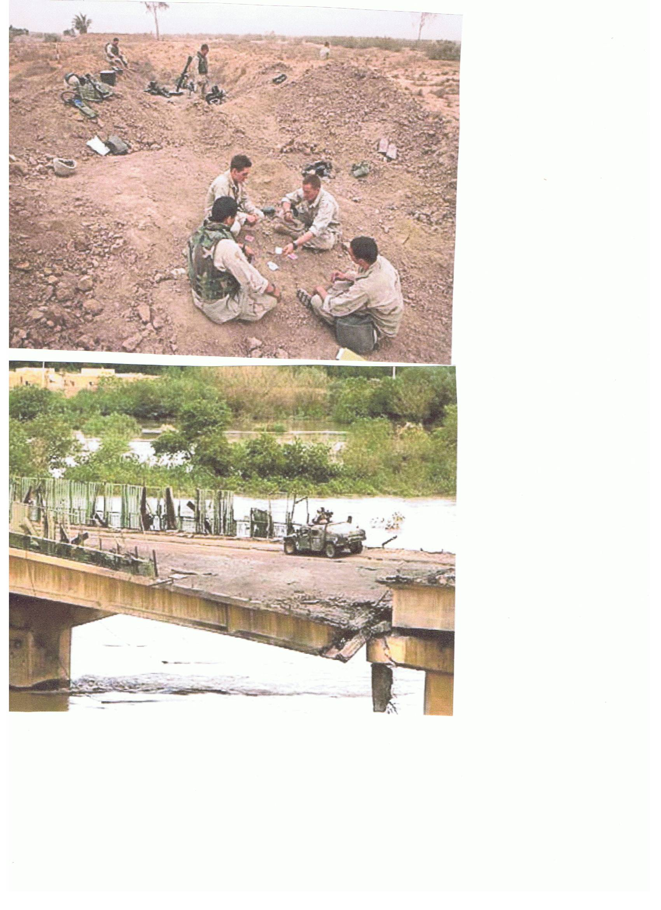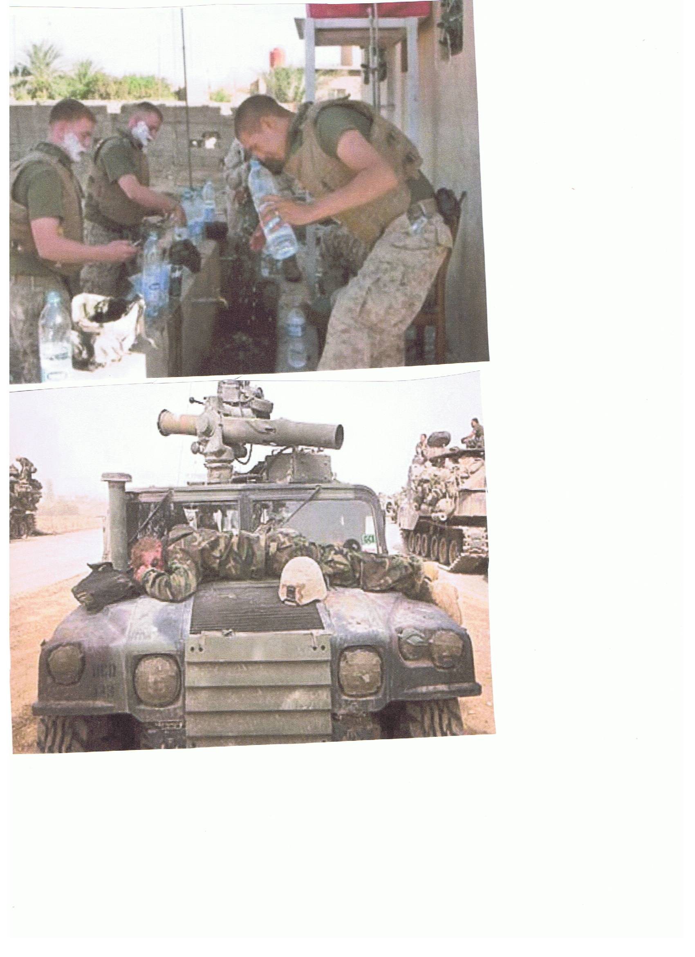
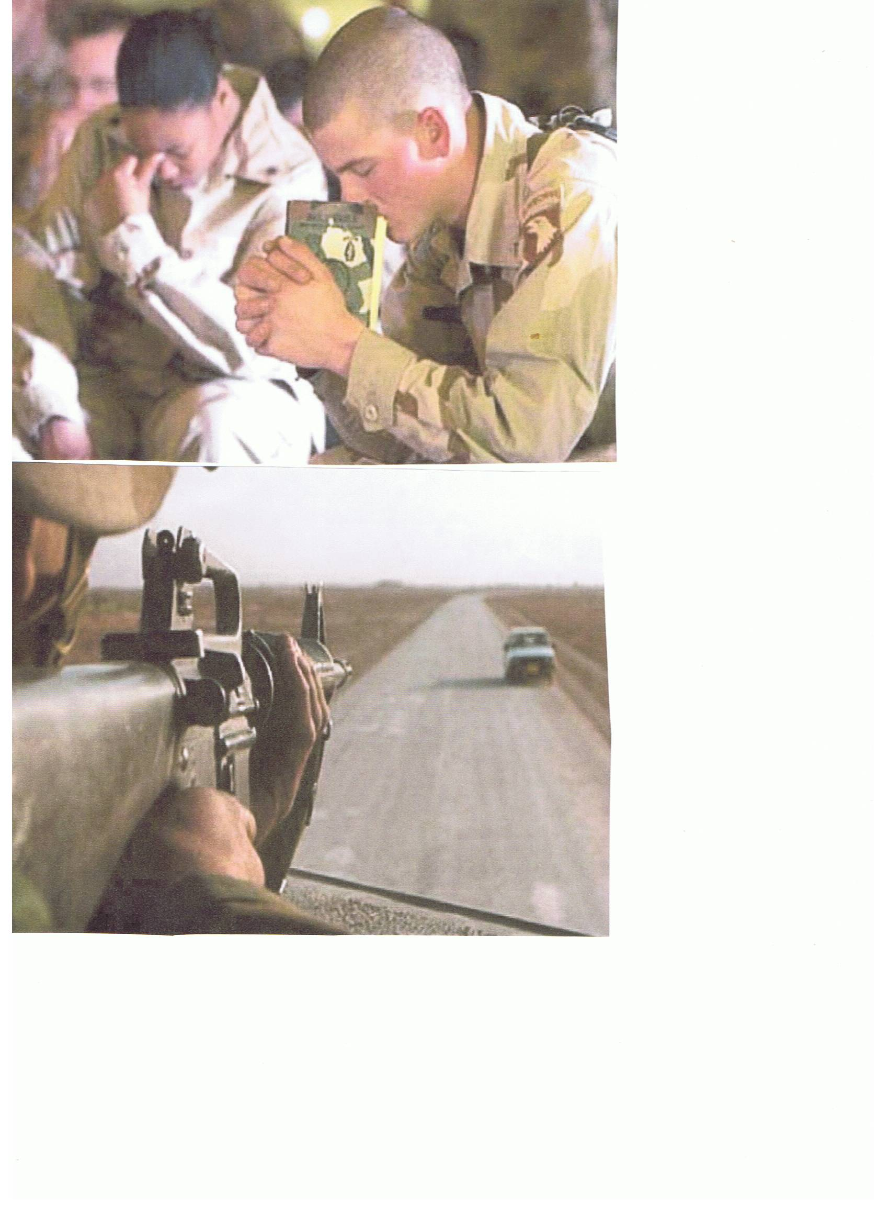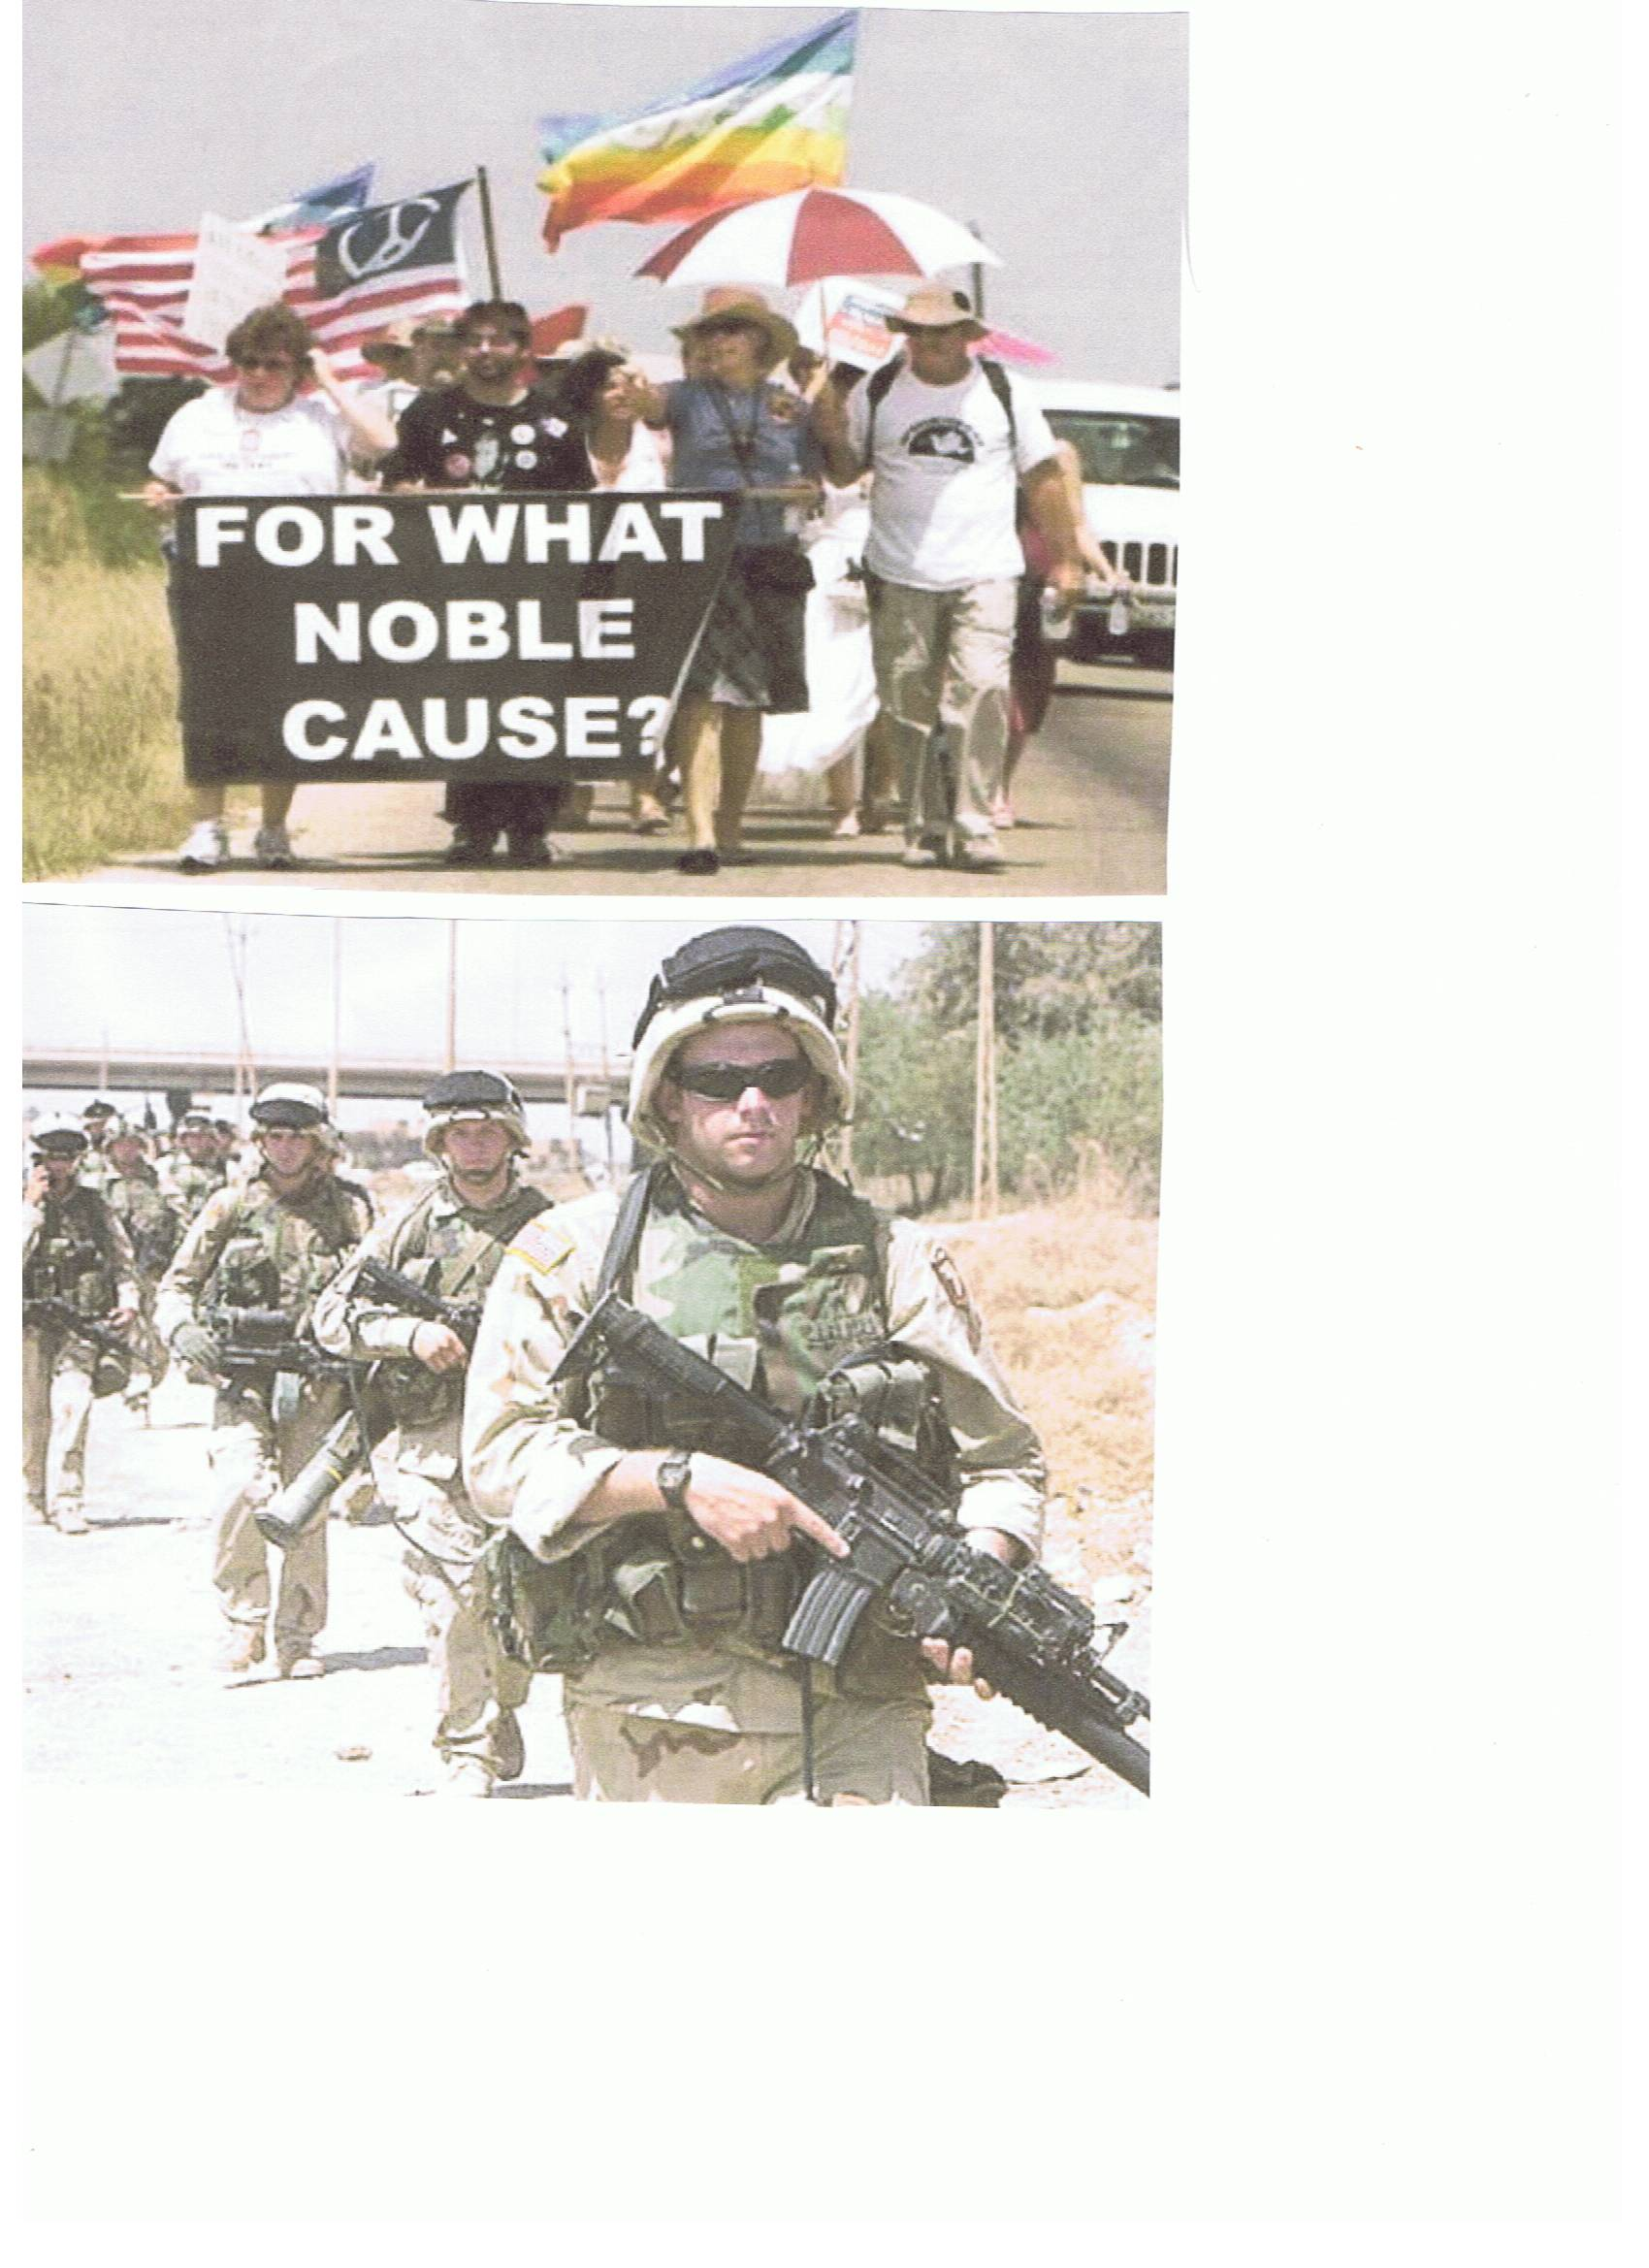
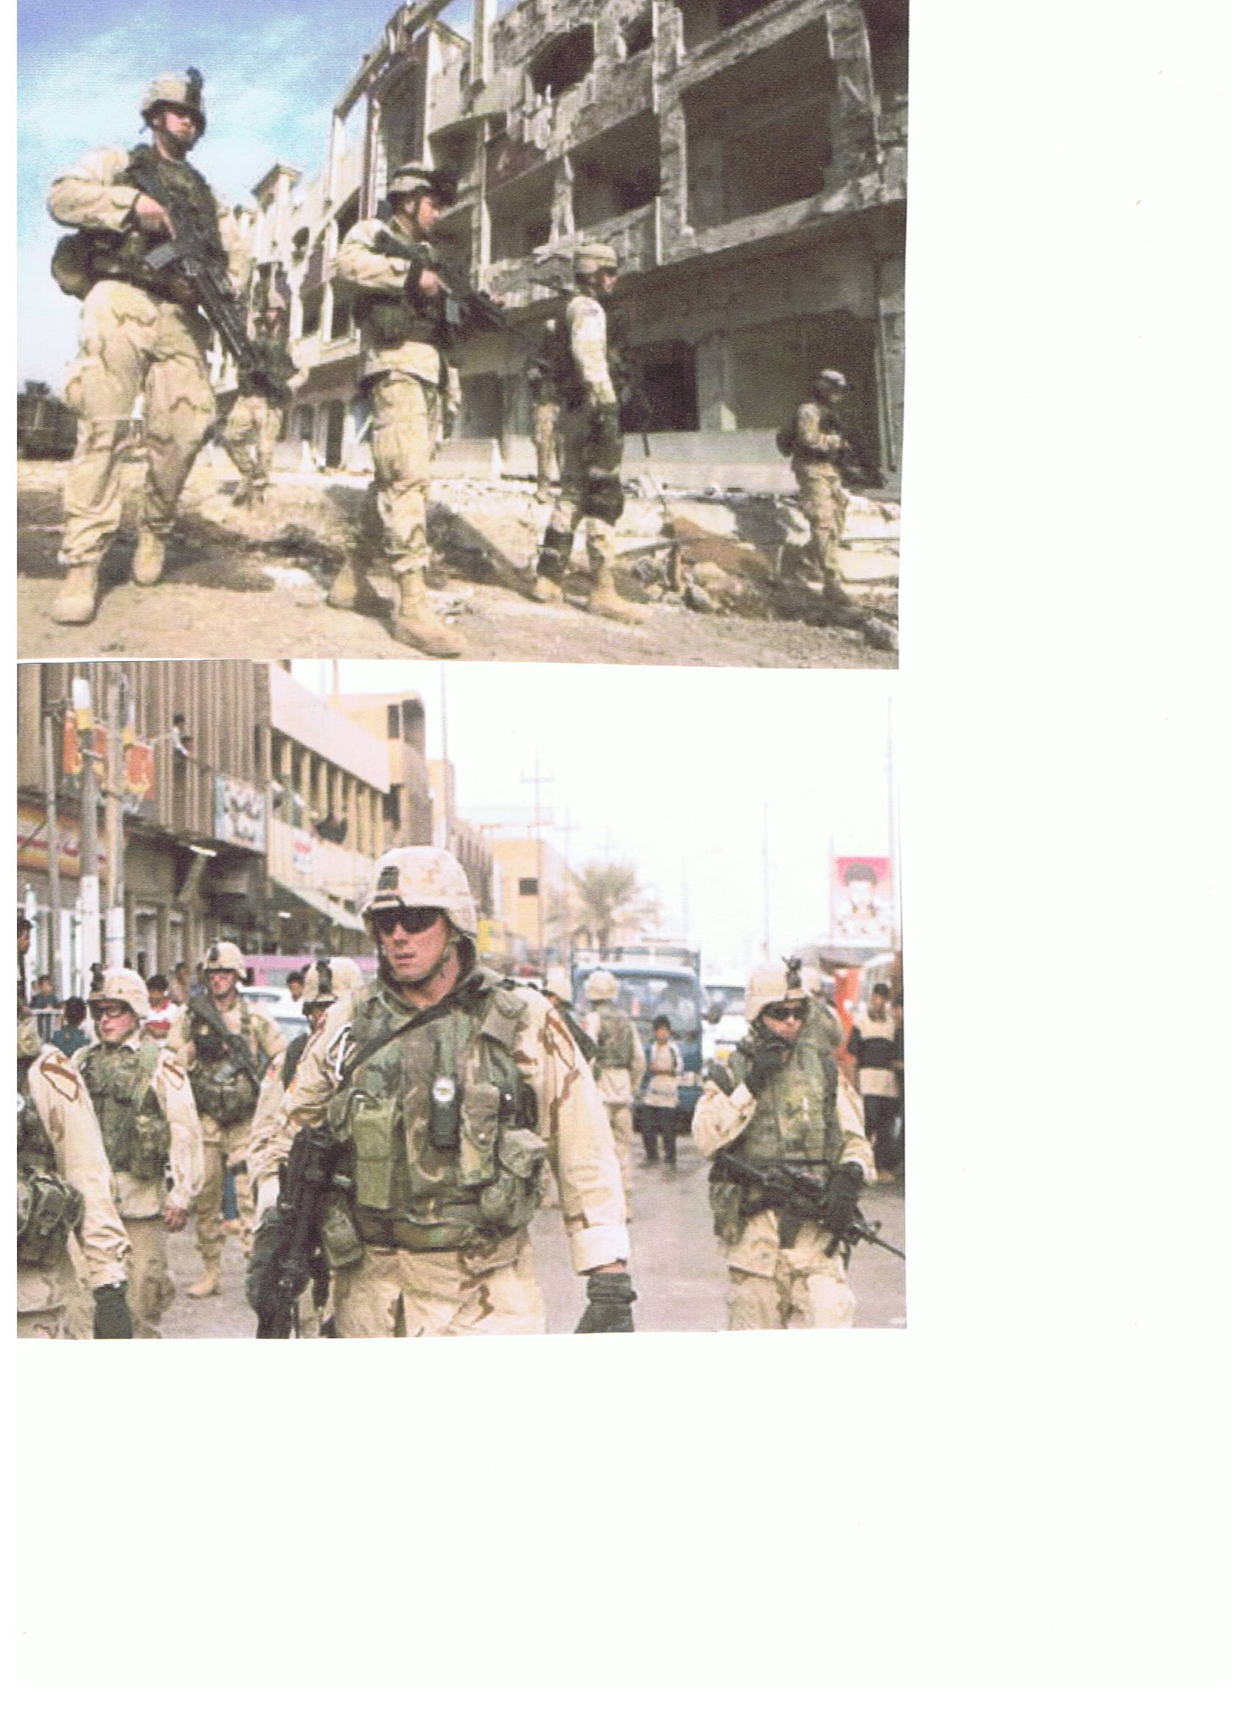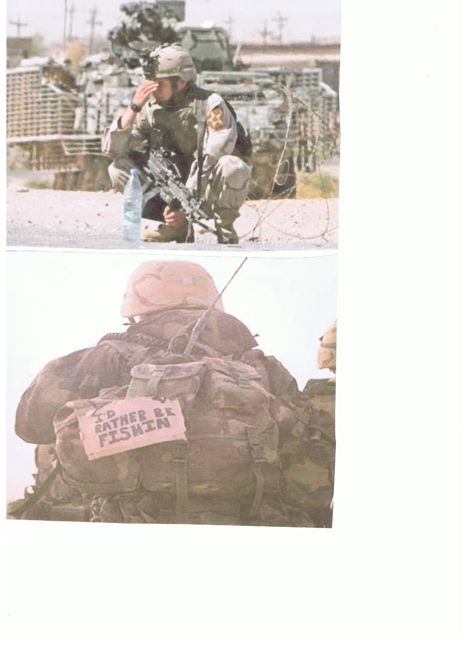
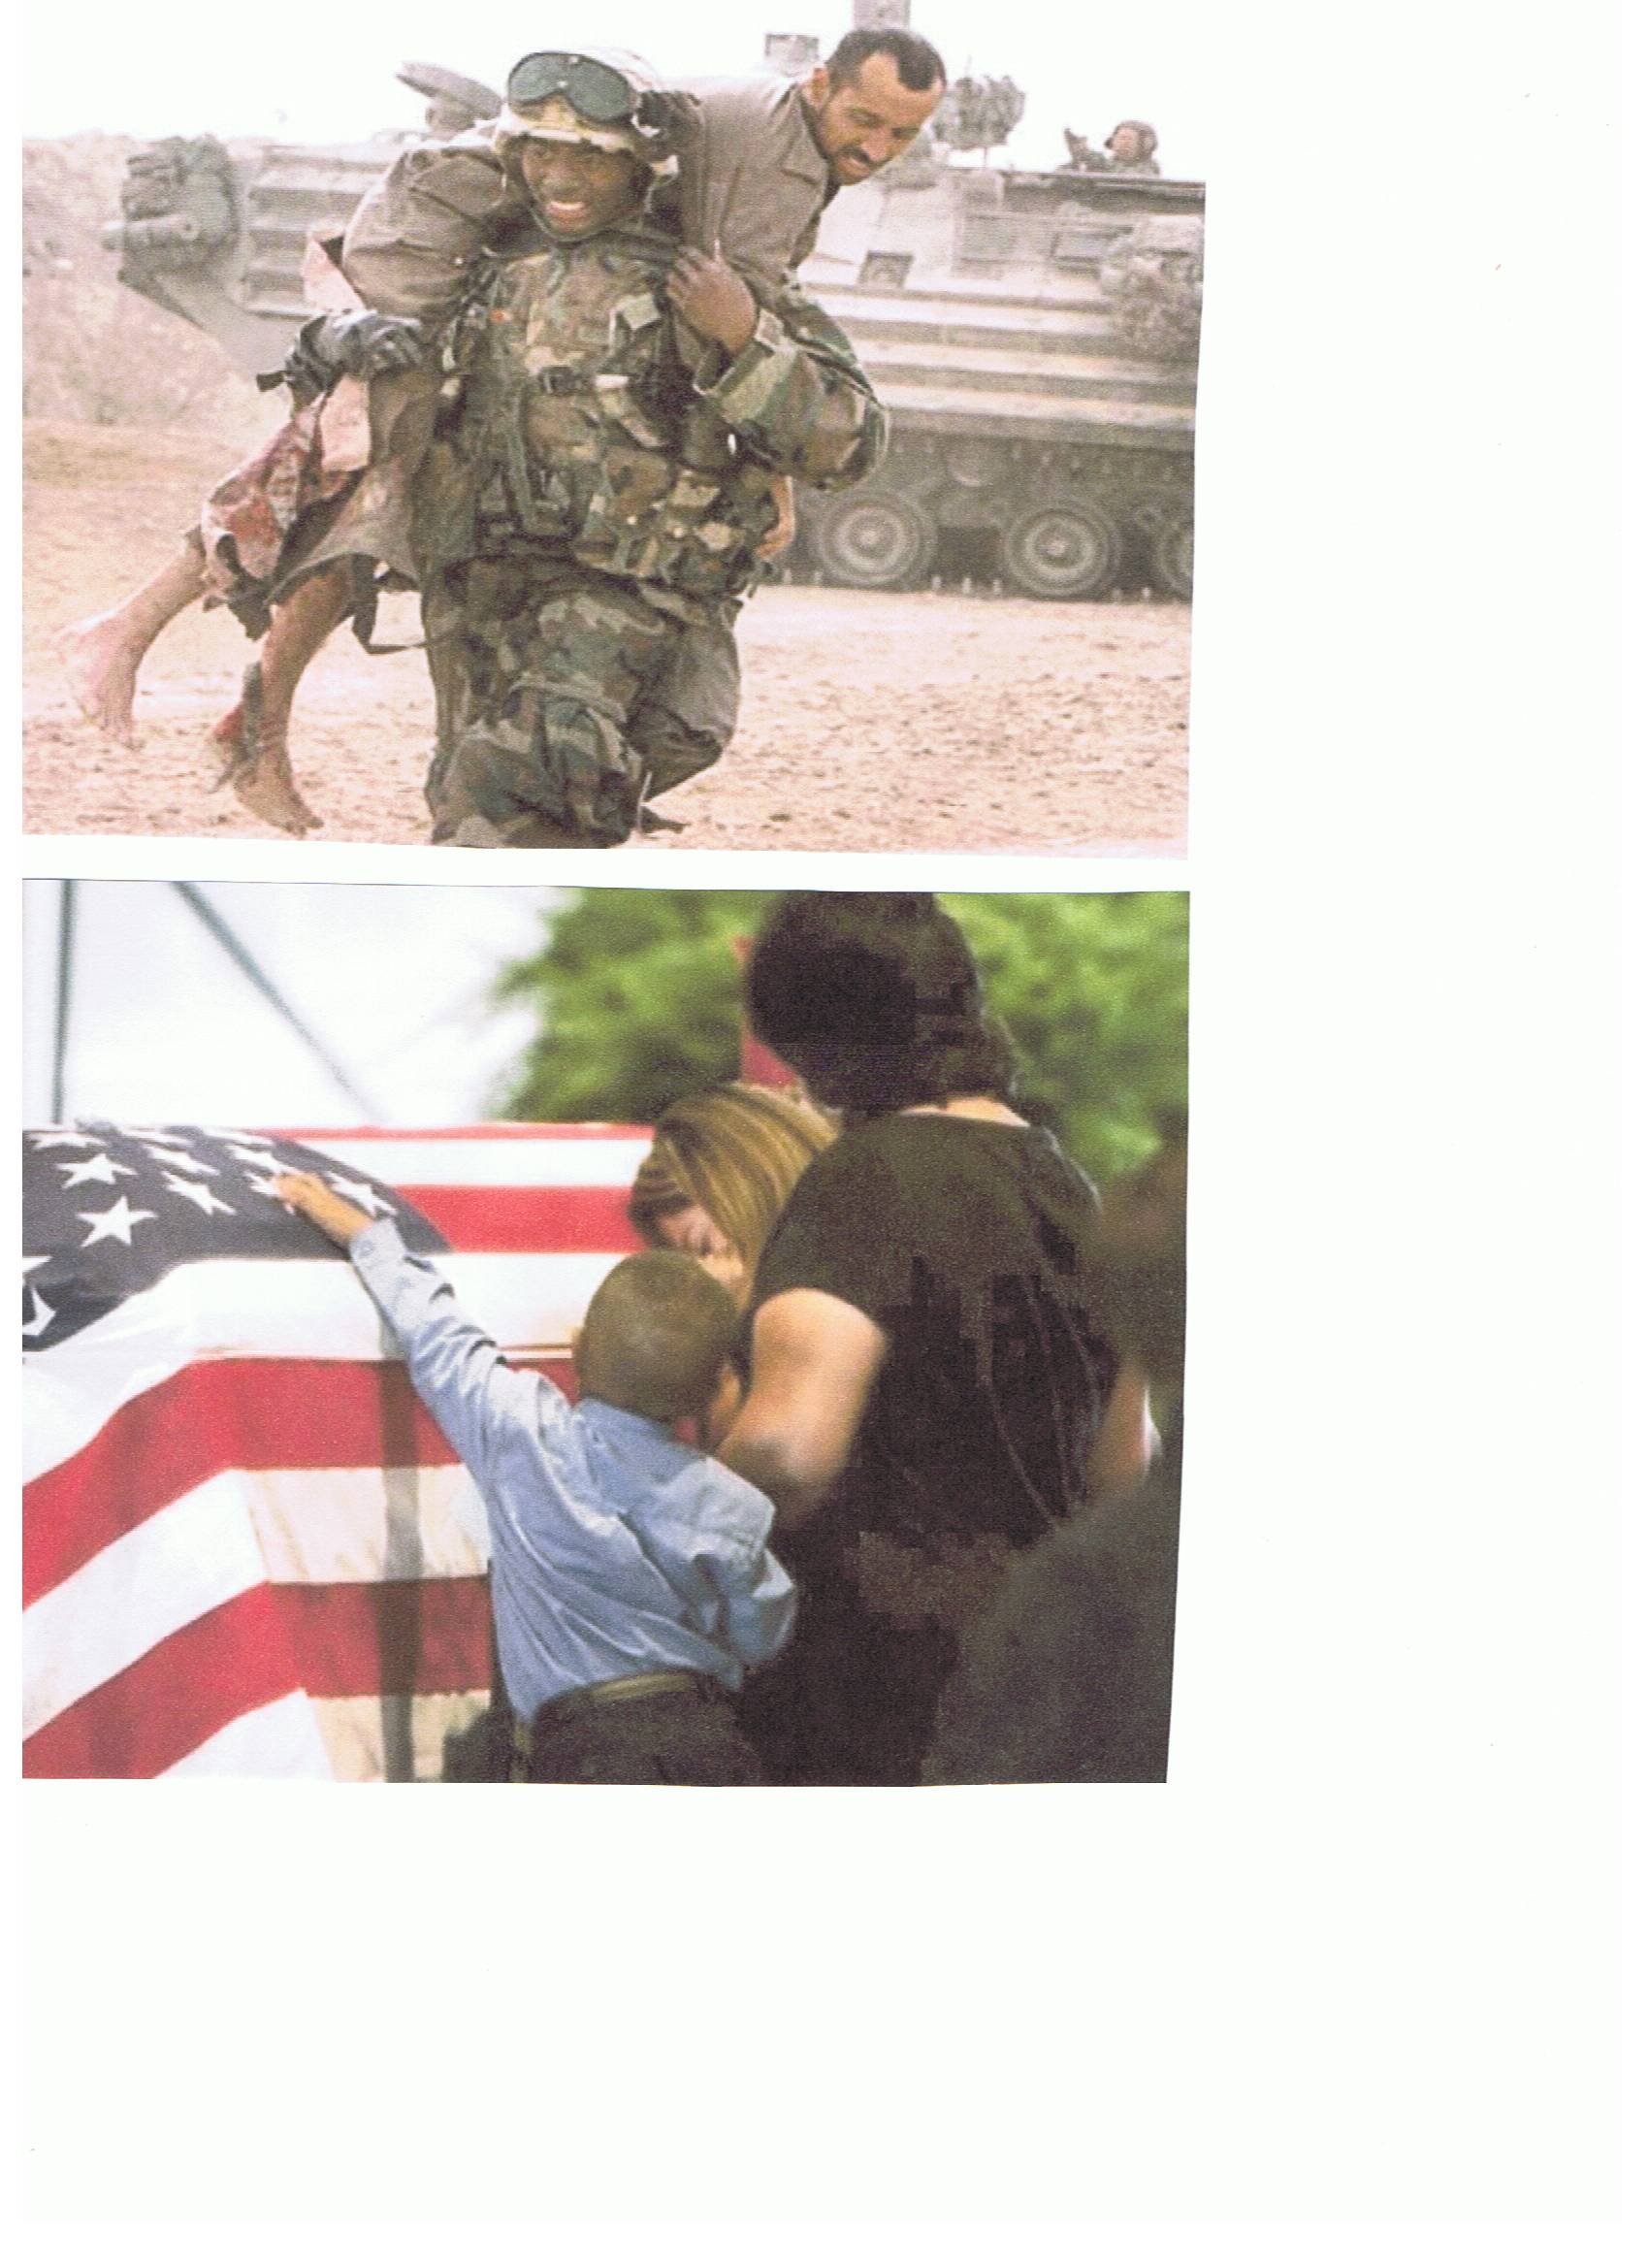
THANK GOD THEY ARE HOME.

ENJOYABLE TIDBITS:
(Jokes, poems, stories, sayings, etc.)
A Laugh a day; helps keep those Blues away, and uplifting items help the Spirit soar.

The Buzzard:

If you put a Buzzard in a pen that is 6 feet by 8 feet and is entirely open at the top, the bird, in spite of its ability to fly, will be an absolute prisoner.

The reason is that a Buzzard always begins a flight from the ground with a run of 10 to 12 feet.

Without space to run, as is its habit, it will not even attempt to fly, but will remain a prisoner for life in a small jail with no top.

The Bat:

The ordinary Bat that flies around at night, a remarkably nimble creature in the air, can not take off from a level place. If it is placed on the floor or flat ground, all it can do is shuffle about helplessly and, no doubt painfully, until it reaches some slight elevation from which it can throw itself into the air. Then, at once it takes off like a flash.

The Bumble Bee:

A Bumble Bee, if dropped into an open tumbler, will be there until it dies, unless it is taken out. It never sees the means of escape at the top, but persists in trying to find some way out through the sides near the bottom. It will seek a way where none exists, until it completely destroys itself.

People:

In many ways, we are like the Buzzard, the Bat, and the Bumble Bee. We struggle about with all our problems and frustrations, never realizing that all we have to do is look up.

